# AWS IAM - EC2 access to S3 Buckets using IAM Role :

IAM user, group and roles

Inline and managed policy

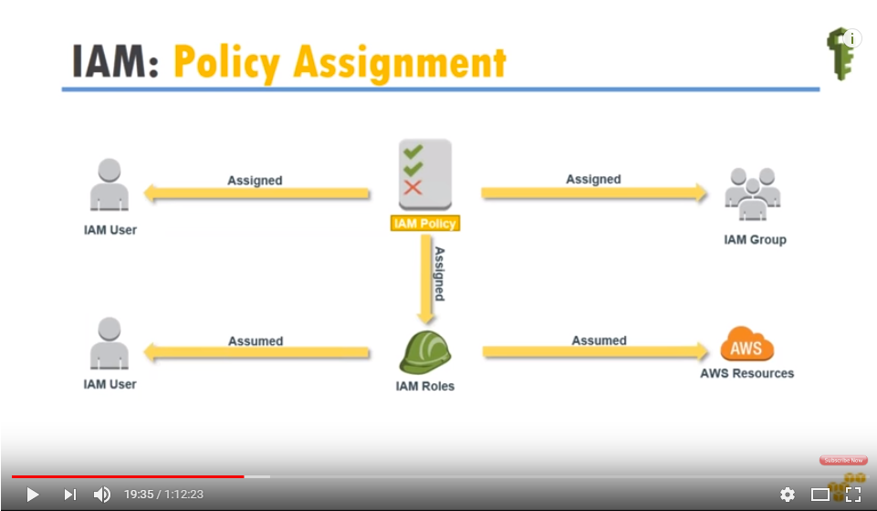

# <https://www.youtube.com/watch?v=pmemtFjlApQ>